# **CTF Challenge: Scanning Website - Using ThreatMiner**



# **1. Introduction**



ThreatMiner collects and analyzes threat intelligence data to help you understand and respond to internet threats. This challenge will introduce you to using ThreatMiner to gather information about a specific IP address.

# **2. Tools and Requirements**

Access to the Internet and ThreatMiner

# **3. Scenario**

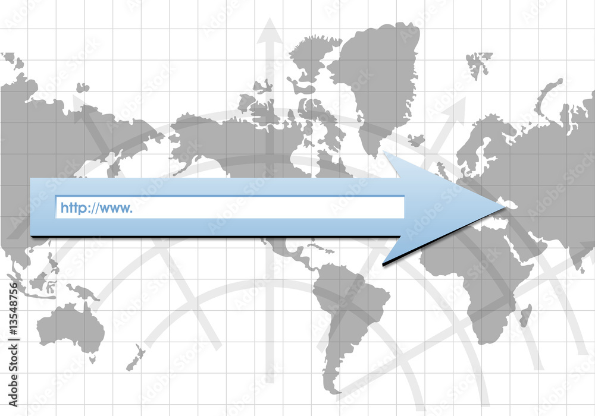

You are an ethical hacker tasked with gathering information about a specific IP address using ThreatMiner. Your job is to determine if the IP address has been flagged for any malicious activity and identify one recent activity associated with it.

# **4. Process to follow while performing CTF**

1. Visit ThreatMiner: [**https://www.threatminer.org/**](https://www.threatminer.org/)

2. Enter the URL [**www.pinterest.com**](http://www.pinterest.com) in the search bar and start the search.

3. Solve the CTF.

**5. Let’s Begin the Challenge**

**Question**

**Flag 1: Is registrant info provided? (yes/no)**

*Answer: No*

***Flag 2: When was the domain created? (YY-MM-DD)***

Answer: *2009-11-26*

**Hint**

